**Print Name: ___________________________________ Math 127 – Exam 2 – Spring 2017**

**Version Yin**

**PROBABILITY PART**

**Oath: “*I will not discuss the exam contents with anyone on planet Earth until the answer key is posted to Blackboard.”***

**Sign Name: _____________________________________________________**

**The penalty for cheating on this Exam is a grade of 0% for Math 127 Exam 2.**

**Student Instructions**

**1. This test is graded out of 50 points and counts for 10% of your Math 127 grade. There are 32 questions worth 1.5 points each and 6f is worth 2 points.**

**2. You can use a calculator, but you cannot use your phone. You can use the calculator on the computers if you wish.**

**3. You will need to use www.statcrunch.com. This is the only permitted webpage.**

**4. You are permitted to use one 8.5” by 11” sheet of notes, front and back. You will submit it with your test.**

**You may not use the pink sheet or copies of the pink sheet.**

**You must produce (handwritten or typed up) your own sheet of notes.**

**You may not use copies or scans of any instructor-created Math 127 content or answer keys.**

**5. Show work or points will be deducted. If you only report an answer and it is wrong, you will receive no credit.**

**1a.** Professor Kupe draws on 15% of his days, goes to yoga on 93% of days, and on 14% of days he does both. Draw and label a Venn Diagram.

**1b.** P(Yoga | Draws) = _________________________________________________________________________

**1c.** P(Draws | Yoga) = _________________________________________________________________________

**1d.** Presuming days are independent of each other, use a Binomial distribution to determine the probability that during a 31-day month, he goes to yoga at least 28 times.

Answer: ____________________________________

**1e.** Presuming days are independent of each other, use a Binomial distribution or another method to determine the probability that during a 31-day month, he draws at least one time.

Answer: _____________________________________

**1f.** Presuming days are independent, show the calculation for:

P(Both days on a weekend he does both activities) =

**2.** Suppose the amount of lead a baserunner takes is Uniformly distributed on the interval [5.2 feet, 9.2 feet].

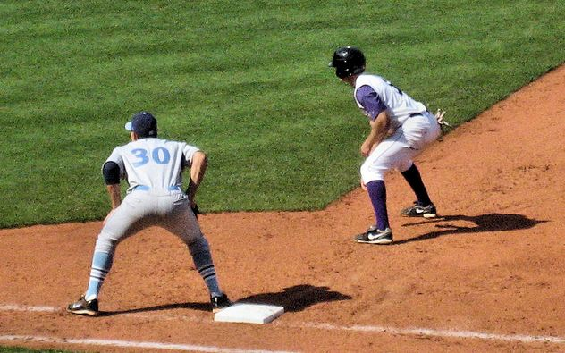

**2a.** Draw the Uniform model. Label your axes, label the height. Give *f(x*) = ___________________________

**2b.** P(Runner leads off at least 7 feet) = ___________________________

**2c.** The 10th percentile is ________________. This means ____________________________________________

_________________________________________________________________________________________

_________________________________________________________________________________________

**2d.** How big of a lead do we expect this baserunner to take? Show calculation:

**3.** The following gambling game has been cooked up by the author of this exam. You will draw a card from a fair deck of 52 cards. We always shuffle up the entire deck for every turn.

|  |  |  |
| --- | --- | --- |
| **Outcome** | **Prize (+) or Payment Owed (–)** | **Probability** |
| Ace | $100 | 4 / 52 |
| King | $75 | 4 / 52 |
| Queen | $50 | 4 / 52 |
| Jack | $25 | 4 / 52 |
| 10 or below | –$25 | 36 / 52 |

In other words, if you draw a 10, 9, …, 3, 2, you owe $25. Get a face card or an ace, and you win money.

**3a.** On any turn, what is the P(Win at least $50) = ____________________

**3b.** Play five times. Lose money on all five turns. What is the probability of that, show the calculation:

**3c.** Calculate the expected amount won / lost when playing this game. Show calculation:

**4.** Time to wait for an elevator at The Palisades apartments in Towson follows a Normal distribution with a mean of 19 seconds but an unknown standard deviation. Professor Kupe collected some data, and 25% of the wait times took 22 seconds or longer. Show the calculations / Normal models to determine the missing standard deviation.

**5.** Time between someone entering or leaving the front door of the Palisades Apartments (during typical business hours) follows an Exponential probability model with a mean of 1.5 minutes.

**5a.** P(No one enters or leaves for at least 5 minutes) = _________________

**5b.** P(Someone arrives or leaves in the next 5 seconds) = ___________________

**5c.** Determine the 90th percentile: __________________

**6.** Rasmussen Reports from March 27, 2017 claims that *p* = 29% of Americans “***Strongly Approved***” of Trump’s presidency. Presuming that figure holds here at the college, we will survey *n* = 10 students randomly from our student population.

**6a.** P(At most 1 student “***Strongly Approves***” of Trump) = ________________________

**6b.** P(A majority “***Strongly Approve***” of Trump) = __________________________

**6c.** P(Exactly 3 students “***Strongly Approve***” of Trump) = _________________________

**6d.** Calculate the mean and show the calculation:

**6e.** Calculate the standard deviation and show the calculation:

**6f.** Using your mean and standard deviation from above, would it be unusual or not unusual if the following numbers of students “***Strongly Approved***” of Trump? Circle each. (0.2 points each)

0 Strongly Approved Unusual Not Unusual

1 Strongly Approved Unusual Not Unusual

2 Strongly Approved Unusual Not Unusual

3 Strongly Approved Unusual Not Unusual

4 Strongly Approved Unusual Not Unusual

5 Strongly Approved Unusual Not Unusual

6 Strongly Approved Unusual Not Unusual

7 Strongly Approved Unusual Not Unusual

8 Strongly Approved Unusual Not Unusual

9 Strongly Approved Unusual Not Unusual

10 Strongly Approved Unusual Not Unusual

**7.** 16-pound bowling balls have weights that follow a Normal model with a mean of 15.97 pounds and a standard deviation of 0.12 pounds.

**7a.** Determine the probability that a randomly selected ball weighs over 16 pounds. Answer: _________________

**7b.** Determine the probability a ball weighs in within 0.05 pounds of the stated 16-pounds.

Answer: _______________________

**7c.** Determine the probability that a ball weighs in within two standard deviations of the mean of 15.97 pounds.

Answer: ________________________

**7d.** Four random bowling balls are pulled off the rack. Calculate the probability that at least one of them is over 16 pounds.

**8.** Calculate the probability of winning on at least one scratch off lottery ticket if the chance of winning on any ticket is 40% and you buy 5 tickets.

**9.** The following table will be used to estimate probabilities for Cecil College.

Rows: Gender  
Columns: Worst Problem

|  |  |  |  |  |  |  |  |  |
| --- | --- | --- | --- | --- | --- | --- | --- | --- |
|  | Artificial intelligence | Disease Epidemic | Global Warming | Non-renewable energy | Over-population | Something Else | Terrorism | Total |
| Female | 9 | 15 | 21 | 8 | 26 | 26 | 50 | 155 |
| Male | 7 | 4 | 9 | 5 | 15 | 18 | 20 | 78 |
| Total | 16 | 19 | 30 | 13 | 41 | 44 | 70 | 233 |

**9a.** P(Terrorism) = ________________________

**9b.** P(Over Population | Male) = ________________________________

**9c.** P(Female | Global Warming) = _______________________________

**9d.** P(Male and said Artificial Intelligence) = ___________________________